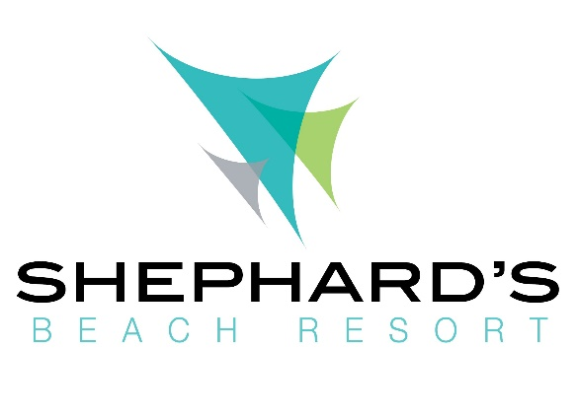
Dear Resort Guest,
First, welcome to Shephard’s Beach Resort. We have doubled our cleaning procedures to ensure the safety and wellbeing of our guests and team members. Our associates will be taking extra precautions to encourage a safe and comfortable experience throughout the Resort.
Along with our most capable housekeeping staff, which were recently awarded AAA’s “Best of Housekeeping Award” for the third year in a row, we have taken our cleaning procedures to a higher level.
Due to the uncertainty of the pandemic, we are maintaining some housekeeping restrictions. Unfortunately, we are not providing daily in-room service. However, between 9 am to 5 pm we will be glad to exchange your towels and trash. Please dial “0” to set up an exchange for fresh towels and trash collection. Please place your dirty towels in the bag provided in your room and dial zero when you are ready to have them picked up. Please do not leave items in the hallways.
We look forward to making your stay enjoyable! Please dial zero if you have any additional questions or requests.
Sincerely, Resort Staff

